Assessment 1: Big Data HDFS Assessment

SRUTHY SUJI
23AD140
AI-DS C

- Create a directory /hadoop/hdfs/ in HDFS
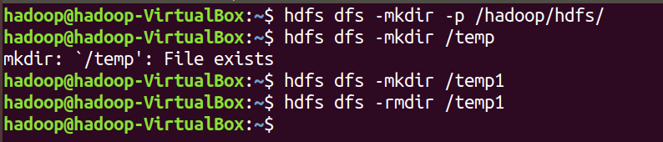

- Create a temp directory in hdfs /temp and run HDFS command to delete “temp” directory.

- Command to list recursively all files in hadoop directory and all subdirectories in hadoop directory
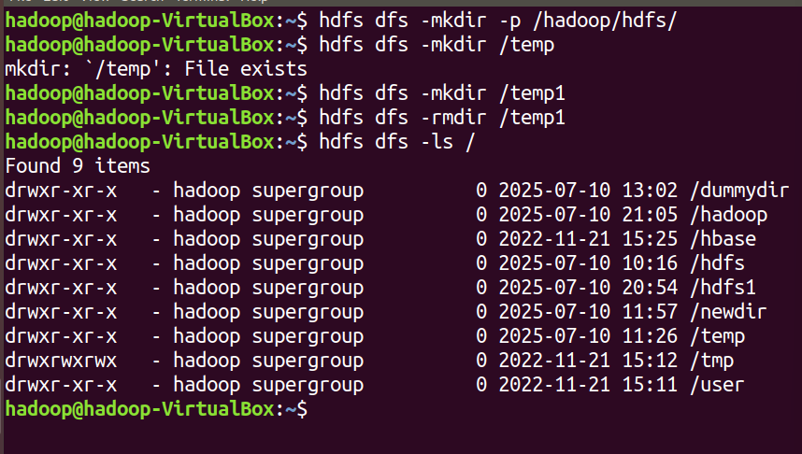

- List all the directory inside /hadoop/hdfs/ directory which starts with 'dir'.
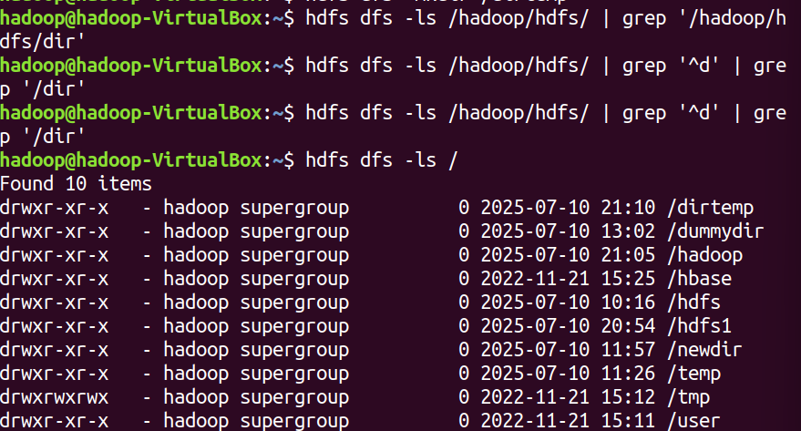

- Create a temp.txt file. Copies this file from local file system to HDFS
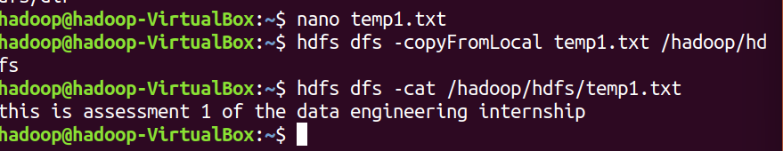

- Command to move from local directory source to Hadoop directory.
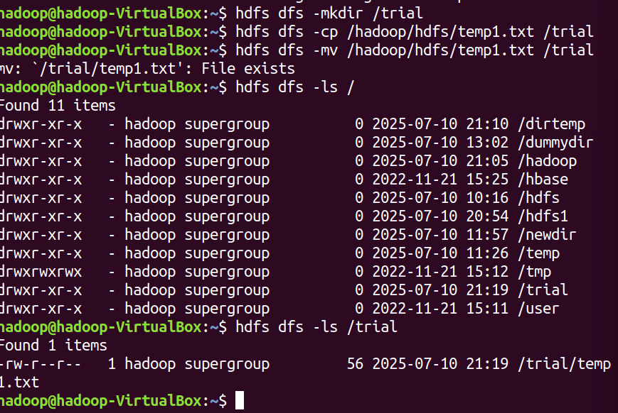

- Display the content of the HDFS file test on your /user/hadoop2 directory.
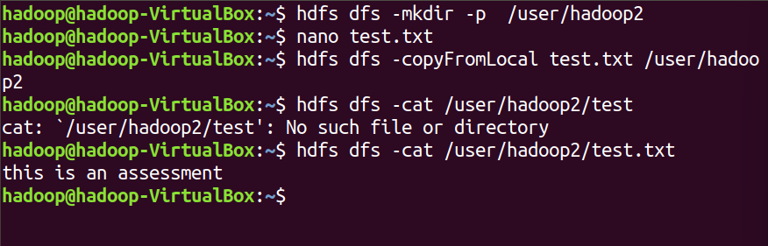

- Upload a compressed file restaurant_dataset.zip to HDFS directory /restautant and then unzip it inside HDFS (not locally). Is it possible? Justify your answer with commands or explanation.
-- it is not possible to unzip it inside the HDFS . it should be Downloaded to the local. It should then be unzipped and uploaded to the uncompressed files
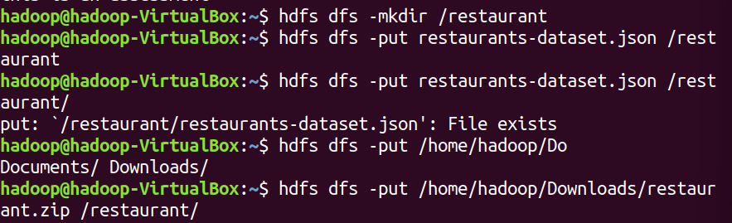

i) Append the content of a local file test1.txt to a hdfs file test2.txt.
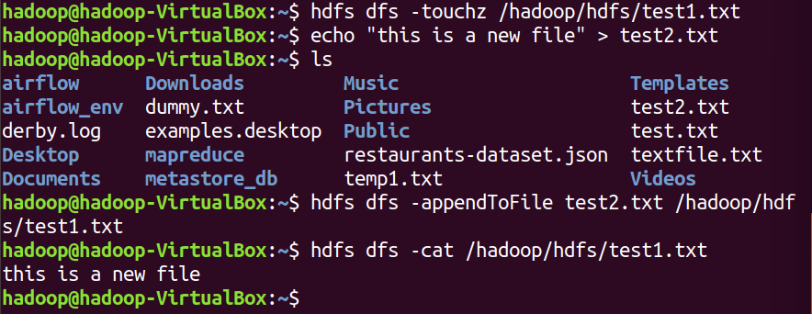

J)Show the capacity, free and used space of the filesystem
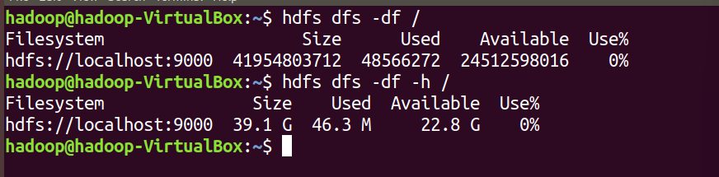

k) Shows the capacity, free and used space of the filesystem. Add parameter Formats the sizes of files in a human-readable fashion.

l) Show the amount of space, in bytes, used by the files that match the specified file pattern.
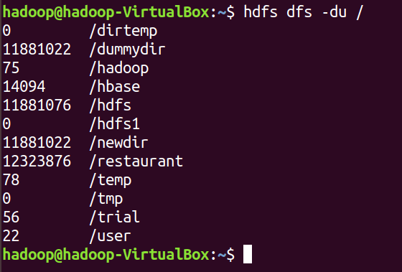

m) Show the amount of space, in bytes, used by the files that match the specified file pattern. Formats the sizes of files in a human-readable fashion.
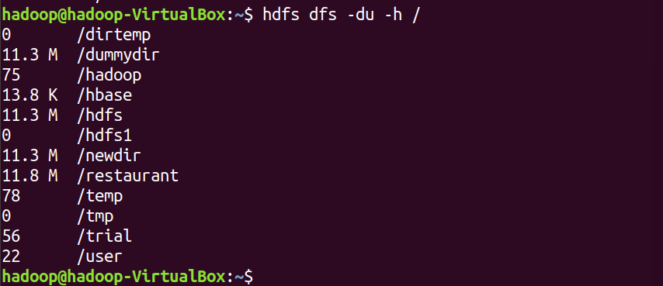

n) Check the health of the Hadoop file system.
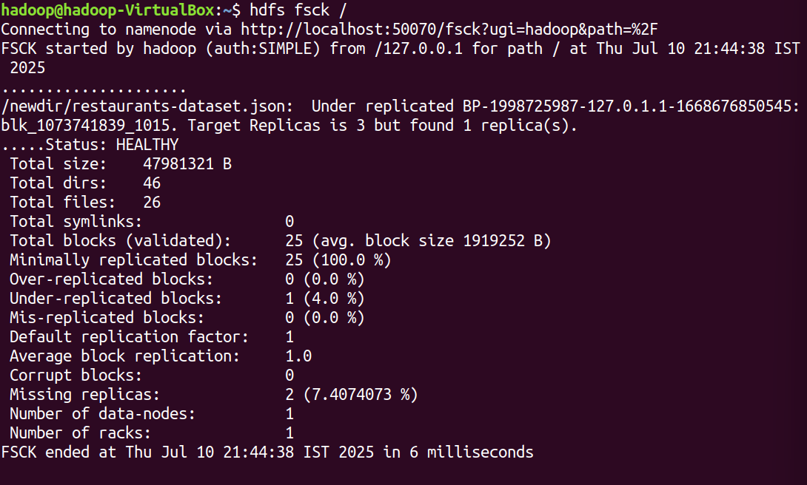

o) Create a file named hdfstest.txt and change it number of replications to 3.

p) Write command to display number of replicas for hdfstest.txt file.


q) Write command to Display the status of file “hdfstest.txt” like block size, filesize in bytes
r) Write HDFS command to change file permission from rw – r – r to rwx-rw-x for hdfstest.txt.

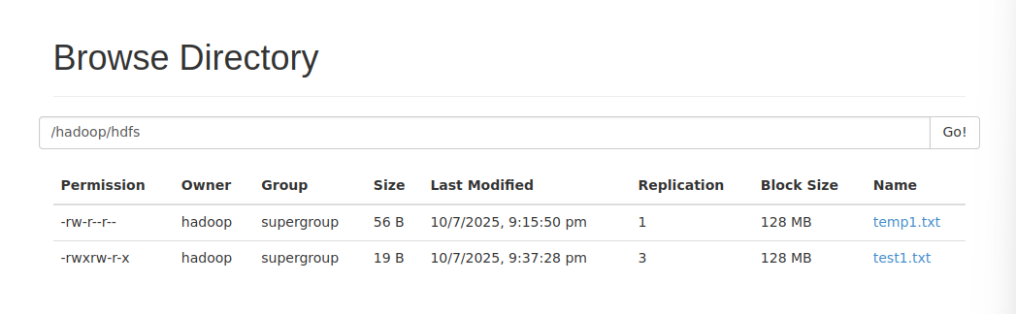

s) Find all files with .csv extenstion and delete all empty files (0 bytes) in HDFS under /hadoop/.
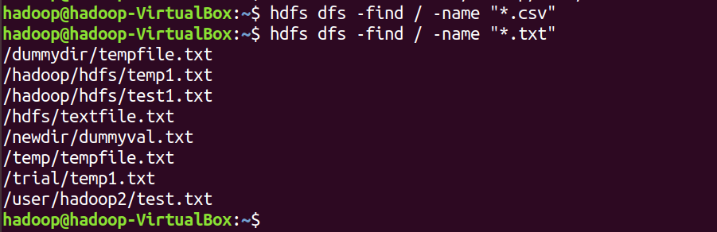

t) Create a snapshot-enabled directory /snapshotdir/. Take a snapshot and delete the snapshot.
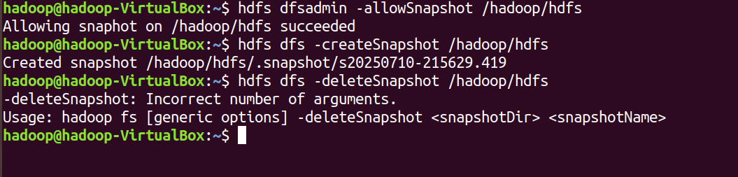

u) Execute a command to generate checksum for an HDFS file hdfstest.txt and explain its purpose.
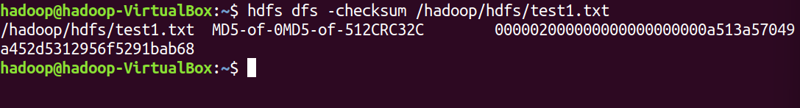

v) Change the blocksize of already existing file in /hadoop/hdfs directory. Is it possible? Justify your answer with commands or explanation.

=> it is Not possible to change the block size directly of an already uploaded file in HDFS

Assessment 2 - Employee Attrition Analysis

Create database “hremployeedb” and create a table “hremp”. Insert all records from file.

- Create database

CREATE DATABASE hremployeedb;
USE hremployeedb;

2.create table
CREATE TABLE hremp (
Attrition VARCHAR(10),
Business_Travel VARCHAR(50),
CF_age_band VARCHAR(50),
CF_attrition_label VARCHAR(50),
Department VARCHAR(50),
Education_Field VARCHAR(50),
emp_no VARCHAR(20),
Employee_Number INT,
Gender VARCHAR(10),
Job_Role VARCHAR(50),
Marital_Status VARCHAR(20),
Over_Time VARCHAR(10),
Over18 VARCHAR(5),
Training_Times_Last_Year INT,
Age INT,
CF_current_Employee VARCHAR(5),
Daily_Rate INT,
Distance_From_Home INT,
Education INT,
Employee_Count INT,
Environment_Satisfaction INT,
Hourly_Rate INT,
Job_Involvement INT,
Job_Level INT,
Job_Satisfaction INT,
Monthly_Income INT,
Monthly_Rate INT,
Num_Companies_Worked INT,
Percent_Salary_Hike INT,
Performance_Rating INT,
Relationship_Satisfaction INT,
Standard_Hours INT,
Stock_Option_Level INT,
Total_Working_Years INT,
Work_Life_Balance INT,
Years_At_Company INT,
Years_In_Current_Role INT,
Years_Since_Last_Promotion INT,
Years_With_Curr_Manager INT
);

- Calculate the cumulative sum of total working years for each department

SELECT Department, `Employee Number`,`Total Working Years`, SUM(`Total Working Years`) OVER (PARTITION BY Department ORDER BY `Employee Number`) AS Cumulative_Total_Working_Years FROM hremp;
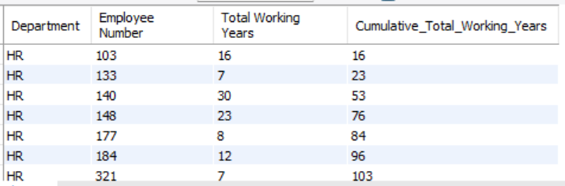

b) Most frequent marital status among employees who left (Attrition = 'Yes')

SELECT `Marital Status`, COUNT(*) AS Count_Leaving FROM hremp WHERE `CF_attrition label` = 'Ex-Employees' GROUP BY `Marital Status` ORDER BY Count_Leaving DESC LIMIT 1;

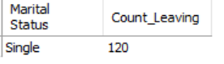

c) Show the Job Role with Highest Attrition Rate (Percentage)

SELECT `Job Role`, ROUND(SUM(CASE WHEN `CF_attrition label` = 'Ex-Employees' THEN 1 ELSE 0 END) * 100.0 / COUNT(*), 2) AS Attrition_Percentage FROM hremp GROUP BY `Job Role` ORDER BY Attrition_Percentage DESC LIMIT 1;

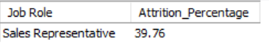

d) Show distribution of Employee's Promotion, Find the maximum chances of employee getting promoted.

SELECT `Years Since Last Promotion`, COUNT(*) AS Employee_Count FROM hremp GROUP BY `Years Since Last Promotion` ORDER BY Employee_Count DESC;
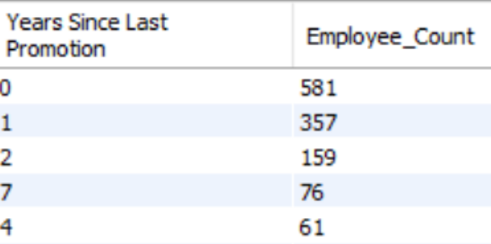

e) Show the cumulative sum of total working years for each department.

SELECT `Department`, `Employee Number`, `Total Working Years`, SUM(`Total Working Years`) OVER (PARTITION BY `Department` ORDER BY `Employee Number`) AS Cumulative_Total_Working_Years FROM hremp;
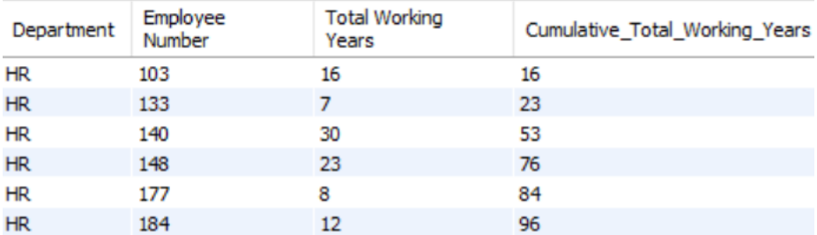

f) Find the rank of employees within each department based on their monthly income

SELECT `Department`, `Employee Number`, `Monthly Income`, RANK() OVER (PARTITION BY `Department` ORDER BY `Monthly Income` DESC) AS Income_Rank FROM hremp;
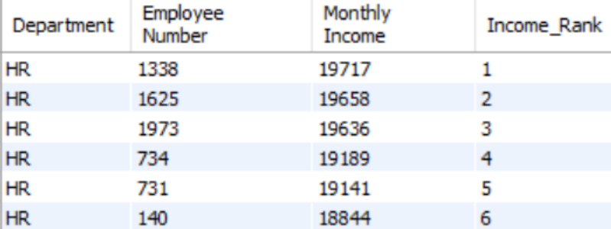

g) Calculate the running total of 'Total Working Years' for each employee within each department and age band.

SELECT `Department`, `CF_age band`, `Employee Number`, `Total Working Years`, SUM(`Total Working Years`) OVER (PARTITION BY `Department`, `CF_age band` ORDER BY `Employee Number`) AS Running_Total_Working_Years FROM hremp;

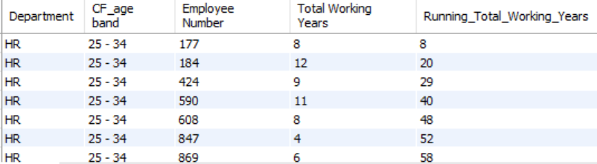

h) Foreach employee who left the organisation (Attrition = Yes), calculate the number of years they worked before leaving and compare it with the average years worked by employees in the same department

SELECT h.`Employee Number`, h.`Department`, h.`Years At Company`, AVG(h2.`Years At Company`) AS Avg_Years_In_Department FROM hremp h JOIN hremp h2 ON h.`Department` = h2.`Department` WHERE h.`CF_attrition label` = 'Ex-Employees' GROUP BY h.`Employee Number`, h.`Department`, h.`Years At Company`;

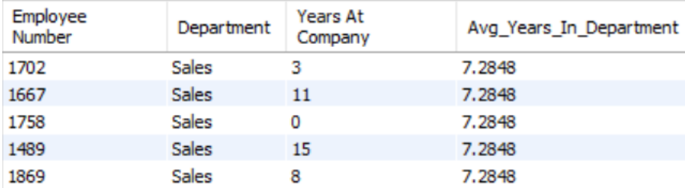

i) Find the if there is any relation between Attrition Rate and Marital Status of Employee.

SELECT `Marital Status`, COUNT(*) AS Total_Employees, SUM(CASE WHEN `CF_attrition label` = 'Ex-Employees' THEN 1 ELSE 0 END) AS Employees_Left, ROUND(SUM(CASE WHEN `CF_attrition label` = 'Ex-Employees' THEN 1 ELSE 0 END) * 100.0 / COUNT(*), 2) AS Attrition_Rate FROM hremp GROUP BY `Marital Status`;

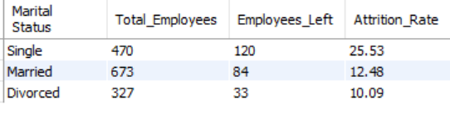

j) Divide employees into 5 groups based on training times last year [Use NTILE ()]

SELECT `Employee Number`, `Training Times Last Year`, NTILE(5) OVER (ORDER BY `Training Times Last Year`) AS Training_Group FROM hremp;

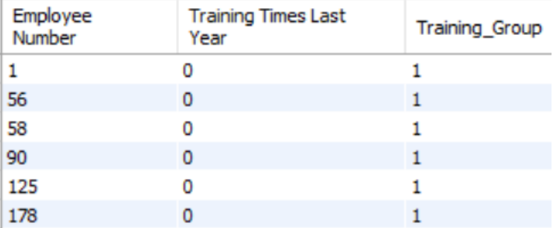

k) Categorize employees based on training times last year as - Frequent Trainee, Moderate Trainee, Infrequent Trainee.

SELECT `Employee Number`, `Training Times Last Year`, CASE WHEN `Training Times Last Year` >= 5 THEN 'Frequent Trainee' WHEN `Training Times Last Year` BETWEEN 3 AND 4 THEN 'Moderate Trainee' ELSE 'Infrequent Trainee' END AS Trainee_Category FROM hremp;

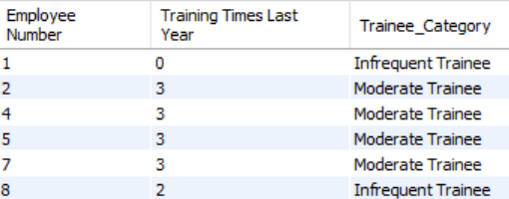

l) Use a CASE WHEN statement to categorize employees into 'Poor', 'Fair', 'Good', or 'Excellent' work-life balance based on their work-life balance score.

SELECT `Employee Number`, `Work Life Balance`, CASE WHEN `Work Life Balance` = 1 THEN 'Poor' WHEN `Work Life Balance` = 2 THEN 'Fair' WHEN `Work Life Balance` = 3 THEN 'Good' WHEN `Work Life Balance` = 4 THEN 'Excellent' ELSE 'Unknown' END AS Work_Life_Balance_Category FROM hremp;

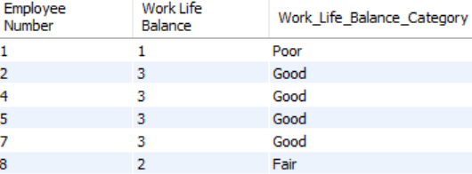

m) Find all possible key reasons for Attrition in Company. Conclude with evidence and explain your answer.

SELECT `Over Time`, `Job Satisfaction`, `Environment Satisfaction`, `Work Life Balance`, AVG(CASE WHEN `CF_attrition label` = 'Ex-Employees' THEN 1 ELSE 0 END) * 100 AS Attrition_Rate FROM hremp GROUP BY `Over Time`, `Job Satisfaction`, `Environment Satisfaction`, `Work Life Balance` ORDER BY Attrition_Rate DESC;

